Right Circular Cylindrical Surface

Definition
# Source: AI Source: Provided by: [Data Path: Persons Table -> ID Column: 1, Name_En Column: Motasem Essam] -> From: [ChatGPT] on [7/20/2026]
A Right Circular Cylindrical Surface is a cylindrical surface whose directrix is a circle and whose generators are perpendicular to the plane of the circular base.
Equivalently, the axis of a right circular cylinder is perpendicular to its circular bases.
It is the standard cylindrical surface commonly associated with a straight circular cylinder.
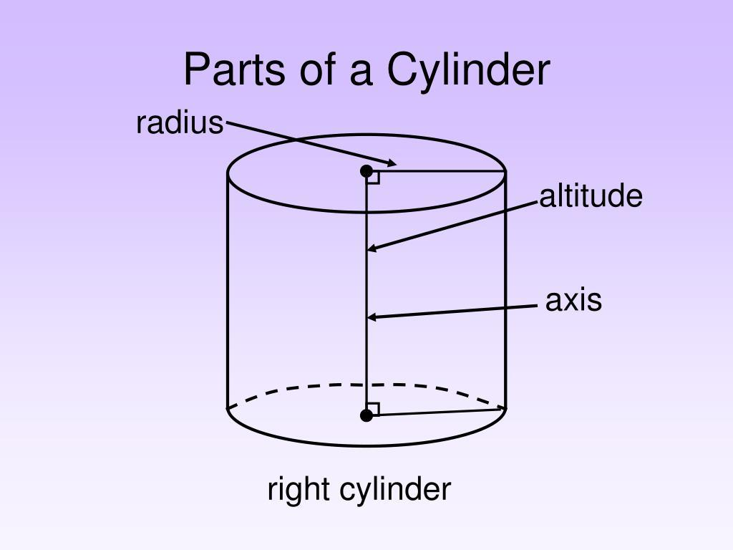
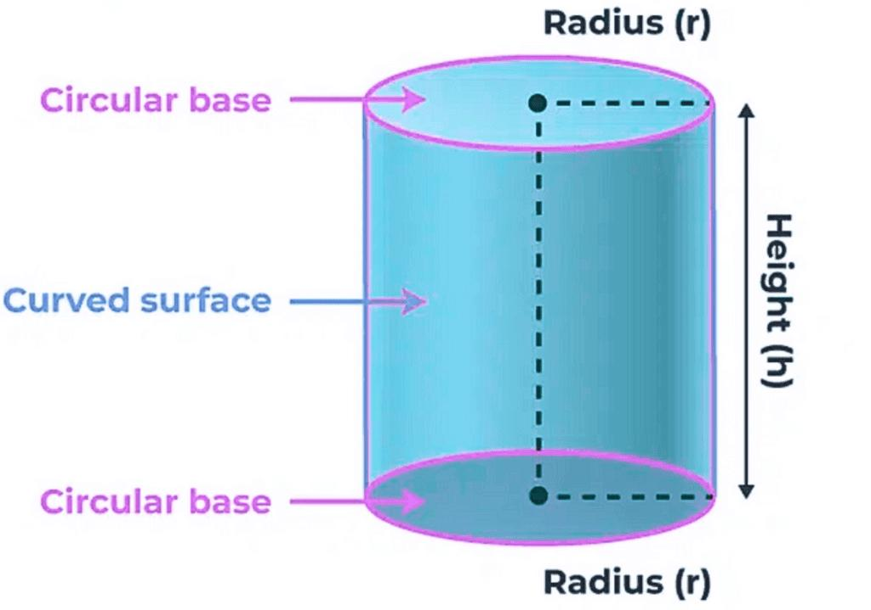
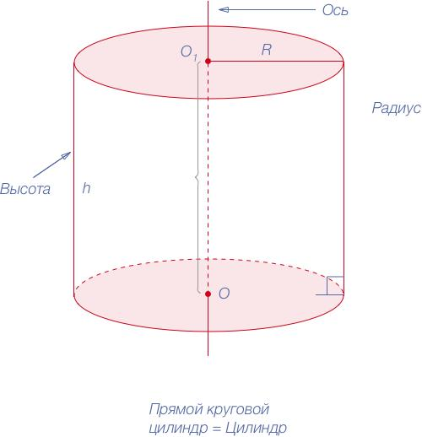
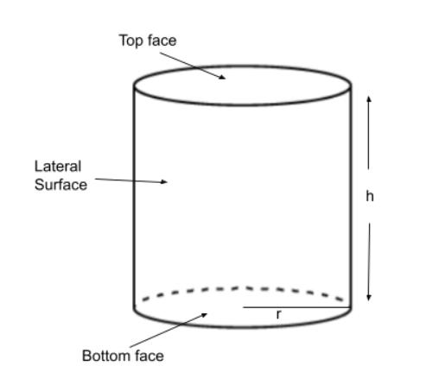

Purpose
# Source: AI Source: Provided by: [Data Path: Persons Table -> ID Column: 1, Name_En Column: Motasem Essam] -> From: [ChatGPT] on [7/20/2026]
A right circular cylindrical surface is used to:
- Describe the lateral surface of a right circular cylinder.
- Calculate curved surface area.
- Study circular surfaces with perpendicular axes.
- Model cylindrical objects with straight vertical sides.
- Represent cylindrical structures using equations.
- Apply geometry and trigonometry to three-dimensional objects.

Fundamental Elements

1. Circular Directrix
# Source: AI Source: Provided by: [Data Path: Persons Table -> ID Column: 1, Name_En Column: Motasem Essam] -> From: [ChatGPT] on [7/20/2026]
The directrix is the circular curve that generates the cylindrical surface.
Its radius is:
$$\boxed{r}$$

2. Generators
# Source: AI Source: Provided by: [Data Path: Persons Table -> ID Column: 1, Name_En Column: Motasem Essam] -> From: [ChatGPT] on [7/20/2026]
The generators are straight line segments that form the cylindrical surface.
For a right circular cylindrical surface, they are:
$$\boxed{\text{parallel to the axis and perpendicular to the base}}$$

3. Axis
# Source: AI Source: Provided by: [Data Path: Persons Table -> ID Column: 1, Name_En Column: Motasem Essam] -> From: [ChatGPT] on [7/20/2026]
The axis passes through the centers of the circular bases.
For a right circular cylinder, the axis is perpendicular to the bases.

4. Radius
# Source: AI Source: Provided by: [Data Path: Persons Table -> ID Column: 1, Name_En Column: Motasem Essam] -> From: [ChatGPT] on [7/20/2026]
The radius $r$is the perpendicular distance from the axis to the cylindrical surface.

5. Height
# Source: AI Source: Provided by: [Data Path: Persons Table -> ID Column: 1, Name_En Column: Motasem Essam] -> From: [ChatGPT] on [7/20/2026]
The height $h$is the perpendicular distance between the two circular bases.
For a right circular cylinder:
$$\boxed{h=\text{distance between the bases}}$$
and the height is parallel to the axis.

Geometric Configuration
# Source: AI Source: Provided by: [Data Path: Persons Table -> ID Column: 1, Name_En Column: Motasem Essam] -> From: [ChatGPT] on [7/20/2026]
A right circular cylindrical surface can be visualized as a circle translated in a direction perpendicular to its plane.
If a circle is:
$$x^{2}+y^{2}=r^{2}$$
and is extended along the $z$-axis, the resulting surface is:
$$\boxed{x^{2}+y^{2}=r^{2}}$$
with a specified range of $z$.
For a finite surface:
$$\boxed{x^{2}+y^{2}=r^{2}, 0≤z≤h}$$
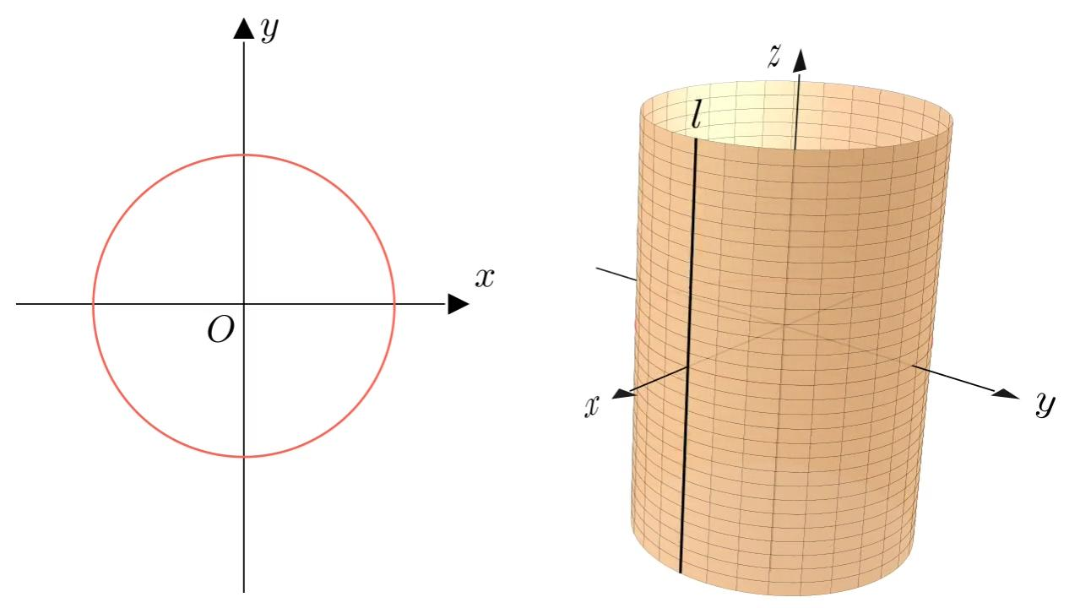
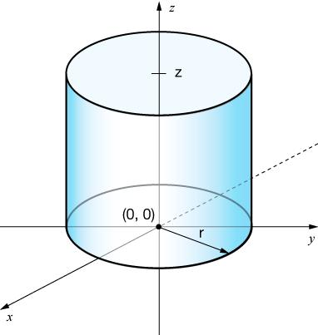
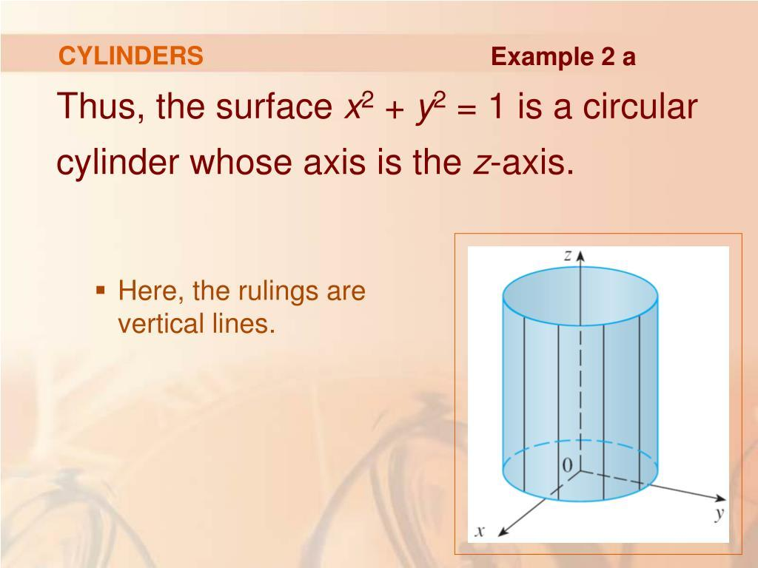
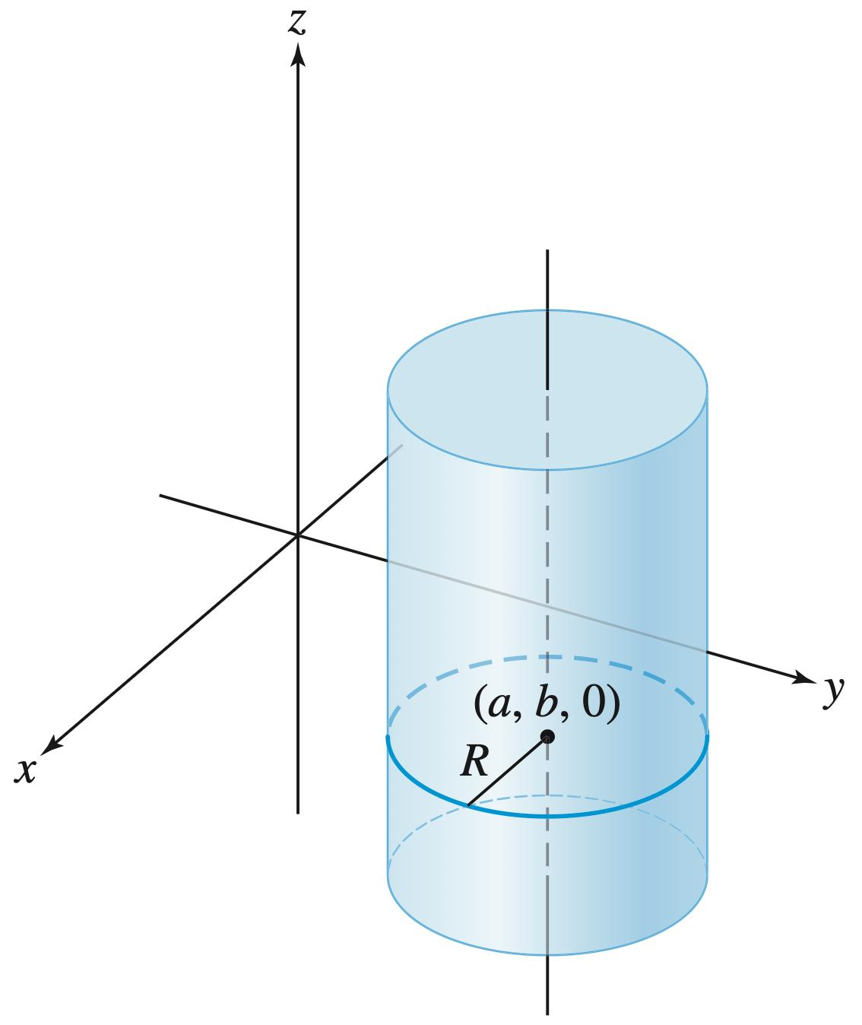

Mathematical Representation
# Source: AI Source: Provided by: [Data Path: Persons Table -> ID Column: 1, Name_En Column: Motasem Essam] -> From: [ChatGPT] on [7/20/2026]
For a right circular cylindrical surface whose axis coincides with the $z$-axis:
$$\boxed{x^{2}+y^{2}=r^{2}}$$
For a finite cylindrical surface:
$$\boxed{x^{2}+y^{2}=r^{2}, 0≤z≤h}$$
Every point $\left(x , y , z\right)$on the surface satisfies:
$$\sqrt{x^{2}+y^{2}}=r$$
Therefore, every point on the surface has the same perpendicular distance from the axis.

Parametric Representation
# Source: AI Source: Provided by: [Data Path: Persons Table -> ID Column: 1, Name_En Column: Motasem Essam] -> From: [ChatGPT] on [7/20/2026]
A right circular cylindrical surface can be represented parametrically by:
$$x=r\cos{θ} \\ y=r\sin{θ} \\ z=t$$
where:
$$0≤θ<2π$$
and, for a finite cylinder:
$$0≤t≤h$$
Here:
- $θ$determines the position around the circular cross-section.
- $t$determines the position along the axis.

Curved Surface Area
# Source: AI Source: Provided by: [Data Path: Persons Table -> ID Column: 1, Name_En Column: Motasem Essam] -> From: [ChatGPT] on [7/20/2026]
The curved surface area of a finite right circular cylindrical surface is:
$$\boxed{CSA=2πrh}$$
where:
- $r$= radius
- $h$= height
The two circular bases are not included.
Derivation
When the cylindrical surface is cut along a generator and unfolded, it becomes a rectangle.
Its:
$$\text{width}=2πr$$
and:
$$\text{height}=h$$
Therefore:
$$CSA=\left(2πr\right)\left(h\right)$$
giving:
$$\boxed{CSA=2πrh}$$
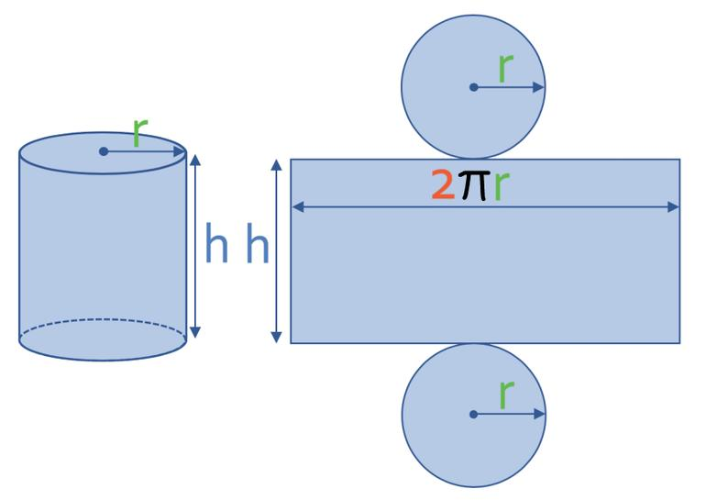
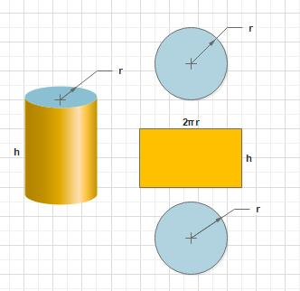
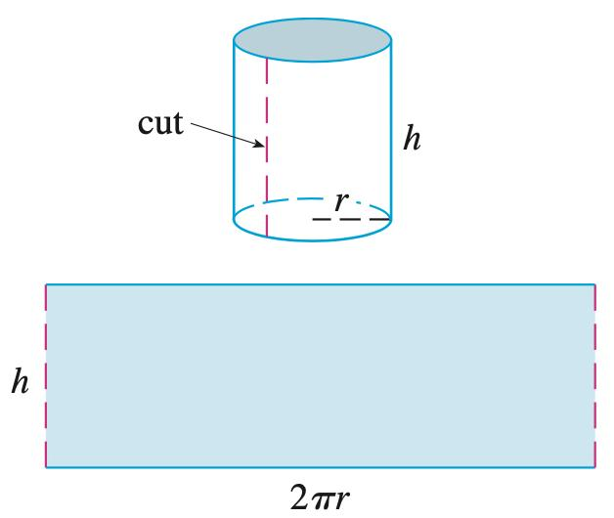
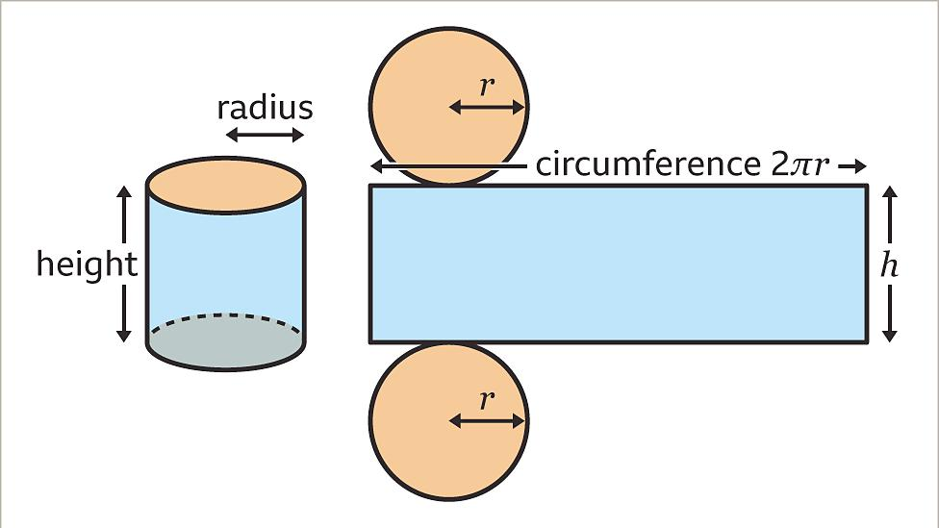
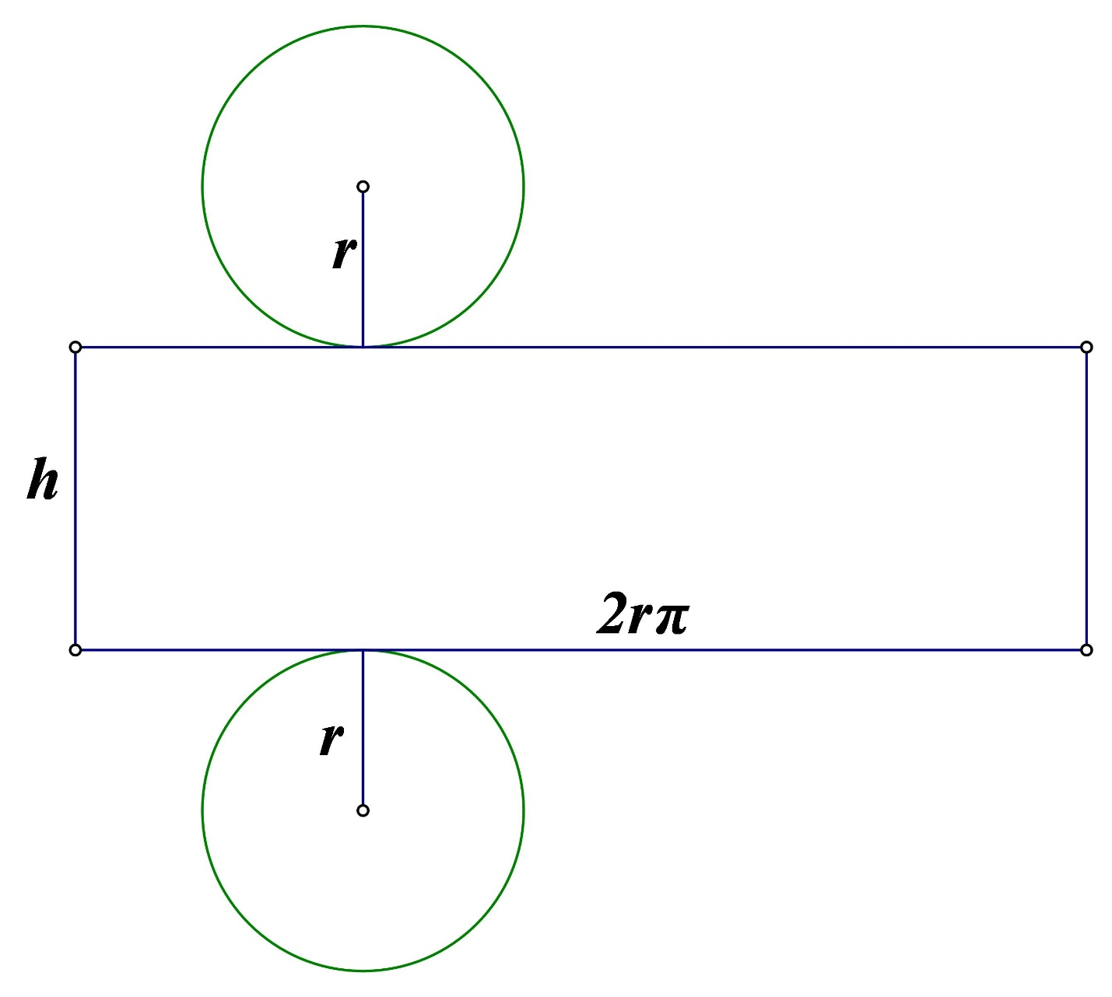

Total Surface Area
# Source: AI Source: Provided by: [Data Path: Persons Table -> ID Column: 1, Name_En Column: Motasem Essam] -> From: [ChatGPT] on [7/20/2026]
If the two circular bases are included:
$$TSA=2πrh+2πr^{2}$$
Therefore:
$$\boxed{TSA=2πr\left(h+r\right)}$$
The distinction is:
$$\boxed{\text{Curved Surface Area}=2πrh}$$
while:
$$\boxed{\text{Total Surface Area}=2πrh+2πr^{2}}$$

Volume of the Corresponding Cylinder
# Source: AI Source: Provided by: [Data Path: Persons Table -> ID Column: 1, Name_En Column: Motasem Essam] -> From: [ChatGPT] on [7/20/2026]
The surface itself does not have volume.
However, the right circular cylindrical surface encloses a corresponding cylindrical solid when its two circular bases are included.
The volume is:
$$\boxed{V=πr^{2}h}$$
This is a property of the cylinder solid, not the lateral surface itself.

Main Properties
# Source: AI Source: Provided by: [Data Path: Persons Table -> ID Column: 1, Name_En Column: Motasem Essam] -> From: [ChatGPT] on [7/20/2026]
A right circular cylindrical surface has the following properties:
- It is a curved surface.
- Its directrix is a circle.
- Its generators are straight lines.
- Its generators are parallel to each other.
- Its generators are perpendicular to the circular bases.
- Its axis is perpendicular to the circular bases.
- Every point on the surface is at a constant perpendicular distance $r$from the axis.
- It has rotational symmetry about its axis.
- It has no vertices.
- The lateral surface has no sharp edges.
- A finite lateral surface has two circular boundary curves.
- Its curved surface area is:
$$\boxed{2πrh}$$
- The lateral surface is an open surface.
- Adding the two circular bases produces a closed surface.

Right Circular vs Oblique Circular Cylindrical Surface
# Source: AI Source: Provided by: [Data Path: Persons Table -> ID Column: 1, Name_En Column: Motasem Essam] -> From: [ChatGPT] on [7/20/2026]
The main distinction is the orientation of the generators relative to the bases.
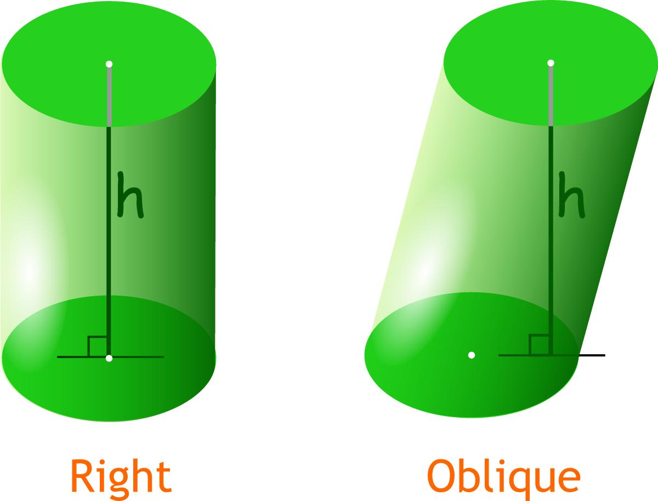
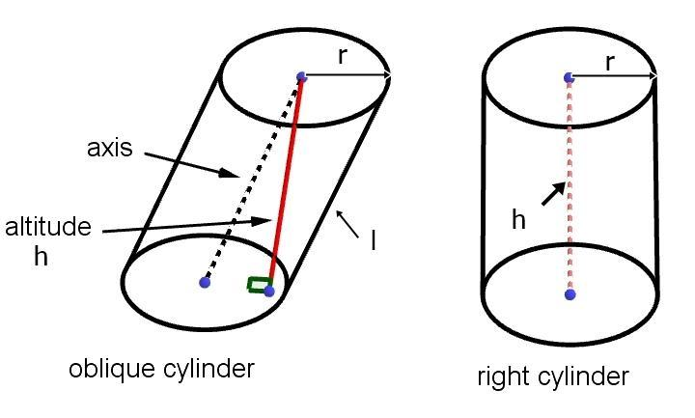
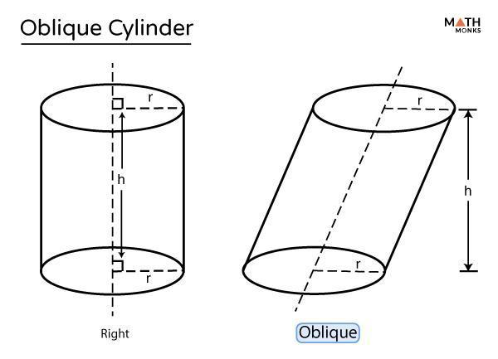
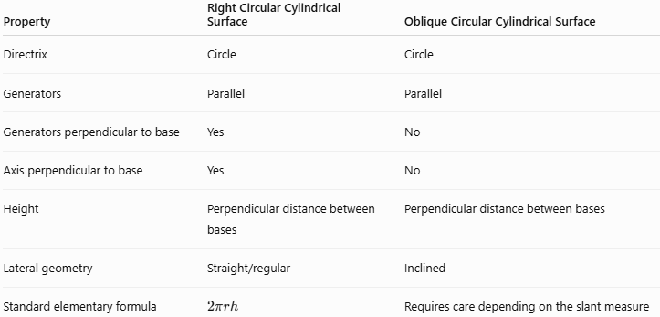
Property | Right Circular Cylindrical Surface | Oblique Circular Cylindrical Surface
Directrix | Circle | Circle
Generators | Parallel | Parallel
Generators perpendicular to base | Yes | No
Axis perpendicular to base | Yes | No
Height | Perpendicular distance between bases | Perpendicular distance between bases
Lateral geometry | Straight/regular | Inclined
Standard elementary formula | $$2πrh$$ | Requires care depending on the slant measure
The word right refers to the perpendicular relationship between the axis and the base.

Right Circular Cylindrical Surface vs Circular Cylindrical Surface
# Source: AI Source: Provided by: [Data Path: Persons Table -> ID Column: 1, Name_En Column: Motasem Essam] -> From: [ChatGPT] on [7/20/2026]
These terms should not be treated as identical.
A Circular Cylindrical Surface means that the directrix is circular.
A Right Circular Cylindrical Surface adds another condition: the generators/axis are perpendicular to the base.
Therefore:
$$\boxed{\text{Right Circular Cylindrical Surface}⊂\text{Circular Cylindrical Surface}}$$
A circular cylindrical surface can therefore be either:
- Right circular
- Oblique circular

Examples

Example 1: Finding Curved Surface Area
# Source: AI Source: Provided by: [Data Path: Persons Table -> ID Column: 1, Name_En Column: Motasem Essam] -> From: [ChatGPT] on [7/20/2026]
A right circular cylindrical surface has:
$$r=5\text{ cm}$$
and:
$$h=12\text{ cm}$$
Using:
$$CSA=2πrh \\ CSA=2π\left(5\right)\left(12\right) \\ \boxed{CSA=120π{\text{ cm}}^{2}}$$
Approximately:
$$\boxed{CSA≈376.99{\text{ cm}}^{2}}$$

Example 2: Finding the Radius
# Source: AI Source: Provided by: [Data Path: Persons Table -> ID Column: 1, Name_En Column: Motasem Essam] -> From: [ChatGPT] on [7/20/2026]
Suppose:
$$CSA=80π{\text{ cm}}^{2}$$
and:
$$h=8\text{ cm}$$
Using:
$$80π=2πrh \\ 80π=2πr\left(8\right) \\ 80π=16πr$$
Therefore:
$$\boxed{r=5\text{ cm}}$$

Example 3: Finding the Height
# Source: AI Source: Provided by: [Data Path: Persons Table -> ID Column: 1, Name_En Column: Motasem Essam] -> From: [ChatGPT] on [7/20/2026]
Suppose:
$$CSA=100π{\text{ cm}}^{2}$$
and:
$$r=5\text{ cm}$$
Then:
$$100π=2π\left(5\right)h \\ 100π=10πh$$
Therefore:
$$\boxed{h=10\text{ cm}}$$

Example 4: Coordinate Geometry
# Source: AI Source: Provided by: [Data Path: Persons Table -> ID Column: 1, Name_En Column: Motasem Essam] -> From: [ChatGPT] on [7/20/2026]
Consider:
$$x^{2}+y^{2}=16$$
This represents a circular cylindrical surface with:
$$r=4$$
whose axis is the $z$-axis.
If:
$$0≤z≤10$$
then the finite right circular cylindrical surface has:
$$r=4, h=10$$
Its curved surface area is:
$$CSA=2π\left(4\right)\left(10\right) \\ \boxed{CSA=80π}$$

Relationship with the Circle
# Source: AI Source: Provided by: [Data Path: Persons Table -> ID Column: 1, Name_En Column: Motasem Essam] -> From: [ChatGPT] on [7/20/2026]
A right circular cylindrical surface can be generated from a circle by translating it along a direction perpendicular to its plane.
Thus:
$$\boxed{\text{Circle}+\text{Perpendicular Translation}→\text{Right Circular Cylindrical Surface}}$$
Every cross-section perpendicular to the axis is a congruent circle.
Therefore:
$$\boxed{\text{All perpendicular circular cross-sections have the same radius}}$$

Relationship with Other Curved Surfaces
# Source: AI Source: Provided by: [Data Path: Persons Table -> ID Column: 1, Name_En Column: Motasem Essam] -> From: [ChatGPT] on [7/20/2026]
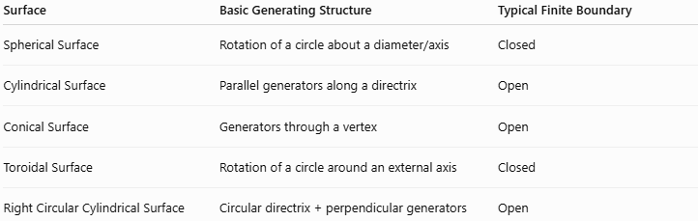
Surface | Basic Generating Structure | Typical Finite Boundary
Spherical Surface | Rotation of a circle about a diameter/axis | Closed
Cylindrical Surface | Parallel generators along a directrix | Open
Conical Surface | Generators through a vertex | Open
Toroidal Surface | Rotation of a circle around an external axis | Closed
Right Circular Cylindrical Surface | Circular directrix + perpendicular generators | Open

Real-World Applications
# Source: AI Source: Provided by: [Data Path: Persons Table -> ID Column: 1, Name_En Column: Motasem Essam] -> From: [ChatGPT] on [7/20/2026]
Right circular cylindrical surfaces are commonly found in:
- Pipes
- Cans
- Water tanks
- Columns
- Pillars
- Rollers
- Shafts
- Cylindrical containers
- Storage tanks
- Metal tubes
- Bottles
- Industrial cylinders
For example, a straight cylindrical pipe is approximately modeled by a right circular cylindrical surface.

Advantages
# Source: AI Source: Provided by: [Data Path: Persons Table -> ID Column: 1, Name_En Column: Motasem Essam] -> From: [ChatGPT] on [7/20/2026]
- Simple and highly symmetric geometry.
- Easy to represent mathematically.
- Straightforward surface-area calculation.
- Circular cross-sections are congruent.
- Easy to unfold into a rectangle.
- Widely applicable to engineering and manufacturing.
- Convenient for coordinate geometry.

Limitations
# Source: AI Source: Provided by: [Data Path: Persons Table -> ID Column: 1, Name_En Column: Motasem Essam] -> From: [ChatGPT] on [7/20/2026]
- The standard equation assumes a convenient coordinate orientation.
- The formula $2πrh$describes the lateral surface.
- The circular bases must be added separately for total surface area.
- Real objects may deviate from perfect circularity or perpendicularity.
- It does not represent oblique or general cylindrical surfaces.

Comparison with Conical Surface
# Source: AI Source: Provided by: [Data Path: Persons Table -> ID Column: 1, Name_En Column: Motasem Essam] -> From: [ChatGPT] on [7/20/2026]
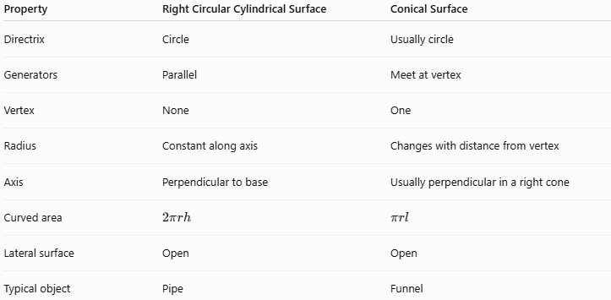
Property | Right Circular Cylindrical Surface | Conical Surface
Directrix | Circle | Usually circle
Generators | Parallel | Meet at vertex
Vertex | None | One
Radius | Constant along axis | Changes with distance from vertex
Axis | Perpendicular to base | Usually perpendicular in a right cone
Curved area | $$2πrh$$ | $$πrl$$
Lateral surface | Open | Open
Typical object | Pipe | Funnel
The key difference is:
$$\boxed{\text{Cylinder: generators remain parallel}}$$
while:
$$\boxed{\text{Cone: generators converge at a vertex}}$$

Key Points
# Source: AI Source: Provided by: [Data Path: Persons Table -> ID Column: 1, Name_En Column: Motasem Essam] -> From: [ChatGPT] on [7/20/2026]
- A Right Circular Cylindrical Surface is a circular cylindrical surface whose axis is perpendicular to its circular bases.
- Its directrix is a circle.
- Its generators are parallel to each other.
- Its generators are perpendicular to the base.
- Its standard equation, with the axis along the $z$-axis, is:
$$\boxed{x^{2}+y^{2}=r^{2}}$$
- For a finite lateral surface:
$$\boxed{x^{2}+y^{2}=r^{2}, 0≤z≤h}$$
- Its curved surface area is:
$$\boxed{CSA=2πrh}$$
- The corresponding cylindrical solid has volume:
$$\boxed{V=πr^{2}h}$$
- The lateral surface is open.
- Adding the two circular bases produces a closed surface.
- It is a specific subtype of circular cylindrical surface:
$$\boxed{\text{Right Circular Cylindrical Surface}⊂\text{Circular Cylindrical Surface}}$$

Conclusion
# Source: AI Source: Provided by: [Data Path: Persons Table -> ID Column: 1, Name_En Column: Motasem Essam] -> From: [ChatGPT] on [7/20/2026]
A Right Circular Cylindrical Surface is a specific type of cylindrical surface characterized by a circular directrix and generators that are perpendicular to the circular bases and parallel to the axis. It is the standard mathematical model for the curved surface of a straight circular cylinder.
Its principal equation is:
$$\boxed{x^{2}+y^{2}=r^{2}}$$
and for a finite lateral surface its curved surface area is:
$$\boxed{CSA=2πrh}$$
For your knowledge-base taxonomy, the most precise placement is:
$$\boxed{\text{Surface}→\text{Curved Surface}→\text{Cylindrical Surface}→\text{Circular Cylindrical Surface}→\text{Right Circular Cylindrical Surface}}$$
This also leaves Oblique Circular Cylindrical Surface as the corresponding orientation-based subtype.

